Memo
To: EMS of Lane County
From: Drs. Skalabrin, Stroke Medical Director and Wilder, Stroke Intervention Medical Director
Re: Recent Guideline Changes for the Treatment of Acute Ischemic Stroke
Date: February 20, 2018

AHA/ASA published 2018 guidelines for the Early Management of Patients with Acute Ischemic Stroke (Stroke, March 2018). Two recent trials, DAWN and DEFUSE, have indicated a significant benefit to acute Ischemic stroke (AIS) patients with an Emergent Large Vessel Occlusion (ELVOs) who receive a thrombectomy within 24 hours of last seen well (LSW) versus standard of care.

What does this mean for EMS?
- This latest information applies to ELVOs and not all strokes.
- It becomes even more important for EMS to identify a C-STAT positive patient, possible ELVO, and communicate this to the Emergency Department.
- Acute ischemic stroke patients who are C-STAT positive and up to 24 hours from LSW should be treated as a Code 3.
- All C-STAT positive patients should receive IV tPA if eligible. Consider the following key points:
- If the patient can be delivered to the endovascular center in less than 2 hours from LSW, bring to endovascular capable hospital for IV tPA and further workup.
- If the patient cannot be delivered to the endovascular center within 2 hours from LSW, but can be delivered to a stroke ready hospital within 2 hours from LSW, bring to the closest stroke ready hospital. Report C-STAT positive status and encourage contact with endovascular capable hospital.
- For C-STAT positive patients who cannot be delivered to any hospital within 2 hours from last seen well, bring to endovascular center for further workup.
Note: Consider ambulance/air rendezvous to minimize transport time. Call ahead to alert endovascular center that patient is C-STAT positive.

Case Study:
- 13:10 a 79 y/o woman working in her yard on the coast, collapsed with left hemiplegia and rightward gaze deviation
- 13:11: 911 activated
- 13:18: EMS at scene and noted positive C-STAT
- 13:24: Air transport contacted
- 13:47: EMS rendezvoused with helicopter at Mapleton Highschool Football Field
- 14:04: Lift-0ff
- 14:25: Arrival at RB helipad
- 14:34: Arrival at RB ED
- NIHSS 19
- Cortical signs:
  - Right-sided eye deviation
  - Left-sided hemiplegia
  - Neglect
  - Left-sided visual field cut
- 14:42: CT: Hyperdense MCA
- 14:43: CT Angiography: Right ICA/MCA occlusion
- 14:49: ELVO Alert
- 14:57: IV tPA (Door to Needle Time: 23 minutes)
- 15:08: Cath Lab arrival
- 15:10: Groin puncture (Door to Groin Time: 36 minutes)
- Right ICA terminus occlusion
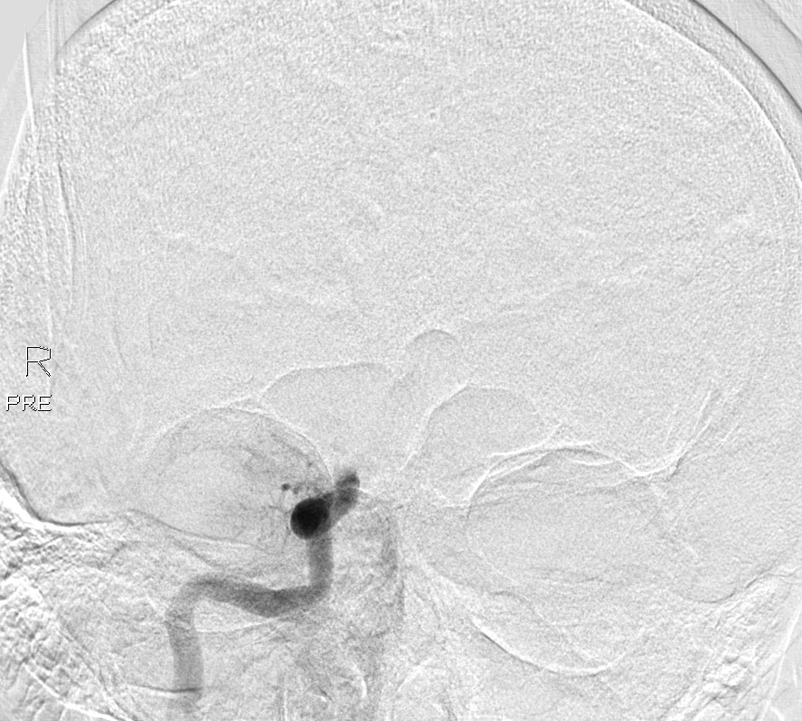
- 15:36: Second pass revascularization
- LSW to revascularization: 2 hours and 26 minutes
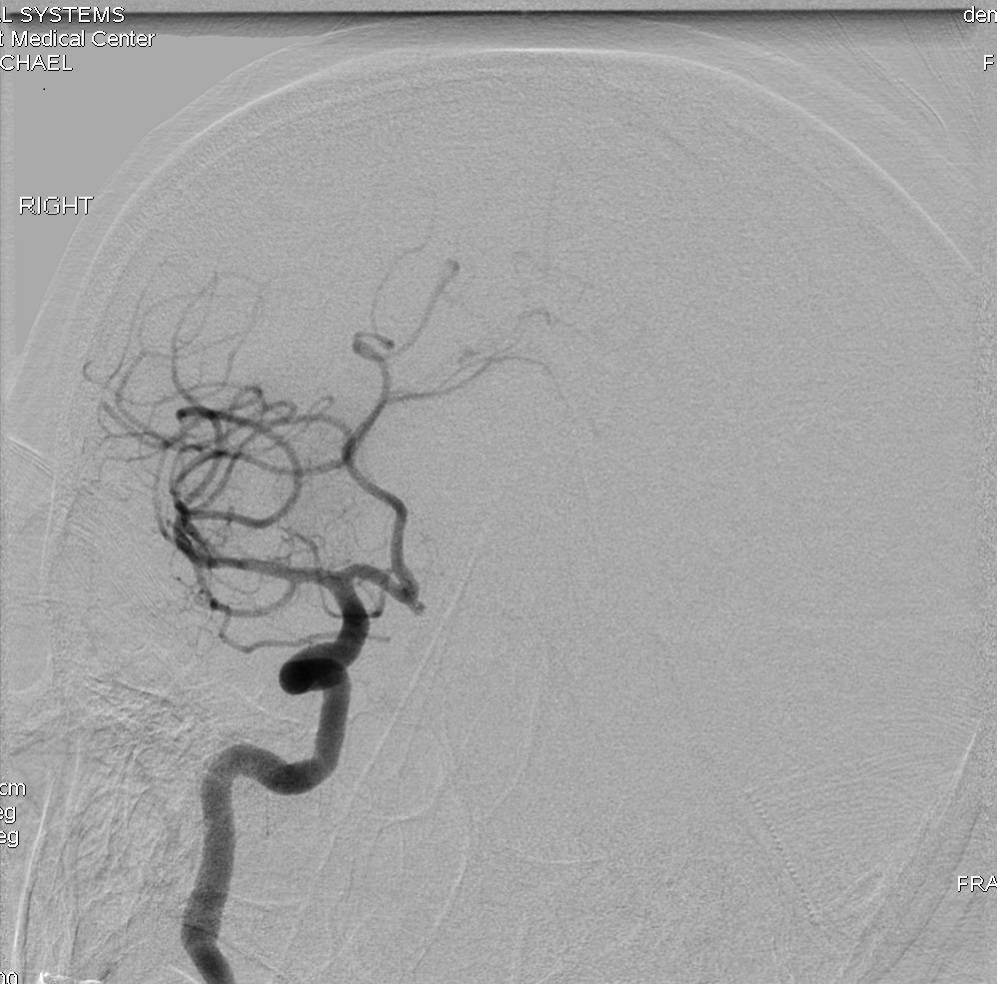
- Discharged home day 3 with mild residual neglect

